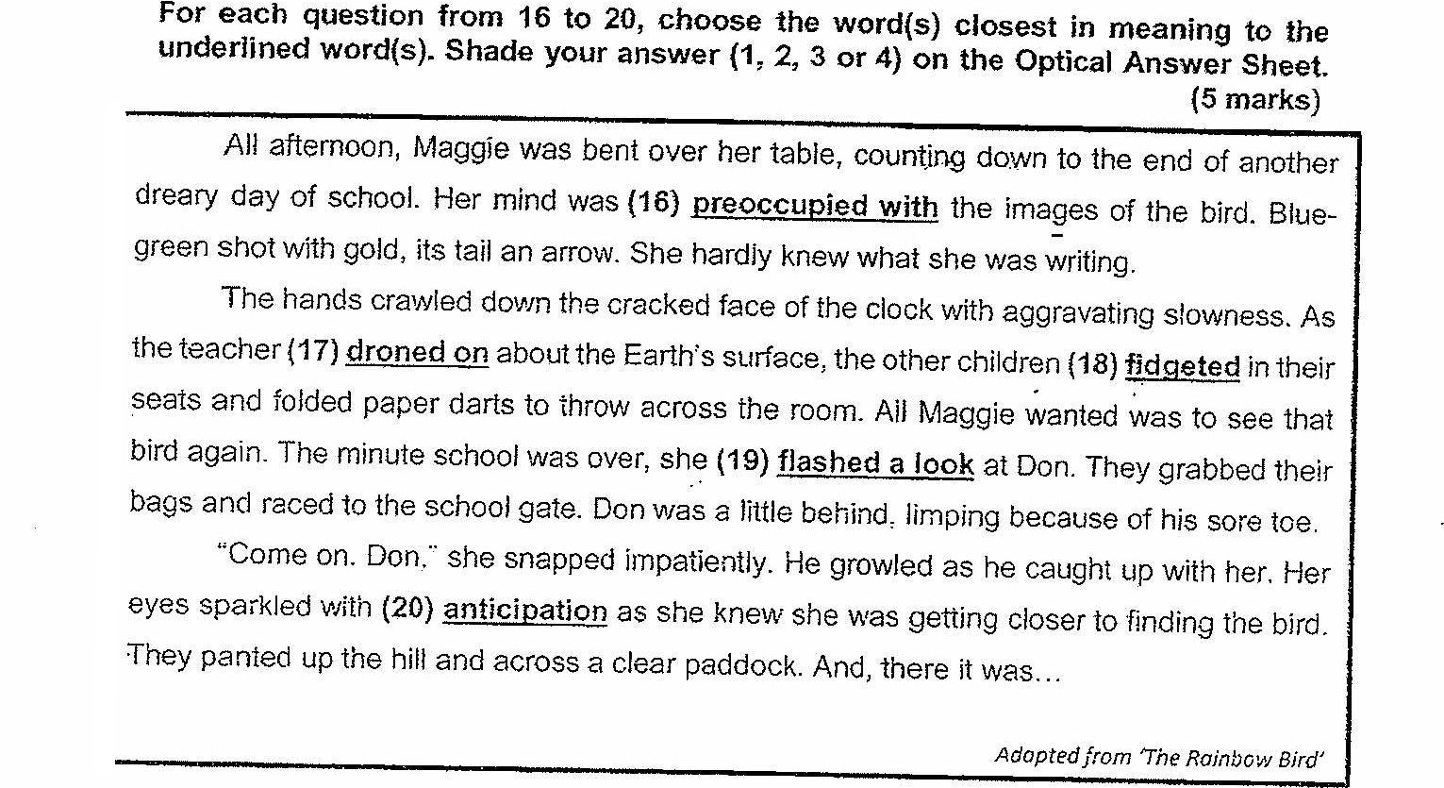

16 (1) oblivious te  
(2) confused by  
(33 enriched with  
(4) consumed by

Ty. (4) spoke softly  
(2) spoke [oudly  
(3) spoke monotonously  
(4) spoke enthusiastically

Ic. fq) quivered  
(2) slumped  
(3) squire!  
(4) shudderes

3 (1) glared  
{2) glanced  
(3) squinted .  
(ay serutinisecd “

20 {1} hope  
(2) affection  
(3) impatience  
(4 apprehension